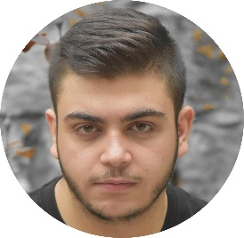

**Professional experiences**

* **Web developer 2021 (Freelancer)**

**My Porfolio :** [**http://dorynehme.live/**](http://dorynehme.live/)

* **Private Tutor**  **2018 – 2020**

**Strengthening in all scientific subjects**

**Ages:8-14.**

**education**

* **Web Development Certificate:** [**https://academy.hsoub.com/certificate/N1JY264O93CCNVVUUF6L.pdf**](https://academy.hsoub.com/certificate/N1JY264O93CCNVVUUF6L.pdf)

**Hsoub Company-2021**

* **Data science – second year student**

**graduation year Expectation: 2022.**

* **Baccalaureate in general Science 2018-2019**  **-**  **Rahbe High School**

**Rahbe, Akkar – Lebanon**

**Skills**

* **Computer skills:**

1. **Microsoft office ( word, powerpoint, excel…)**
2. **VsCode**
3. **Internet (Navigation and Research)**
4. **Git**

* **Programming skills:**

1. **java (oop, data structures and algorithms)**
2. **R programing (R data analysis)**
3. **DataBase (Sql)**
4. **Web Development :**
5. **Html**
6. **Css**
7. **JavaScript and Jquery**
8. **Bootstrap**
9. **Npm Webpack**
10. **Basic Knowledge In Sass**
11. **React js (Front-end)**
12. **Basic Knowledge In laravel 8**

* **Soft skills :**

1. **Respect time**
2. **Learn fast**
3. **Responsible**
4. **creative**

+961 81252142

[doryy.nehme@gmail.com](mailto:doryy.nehme@gmail.com)

19 years old

Lebanese

**Dory Nehme**

**Languages**

1. **Arabic**
2. **English**
3. **French**

**Workshops and training**

1. **A laboratory to incubate innovative ideas for content that promotes religious freedoms (Maharat).**
2. **Workshops to prepare mentors to deal with young people and children**

**Volunteer in:**

1. **Orthodox Youth Movement (MJO) - Mentor for the group (3-14 years)**
2. **All municipal activities**
3. **Assistant at an association to help stray and lost animals**